|  |
| --- |
| Groupe SEB |
| Sales Forecast |
| For Hong Kong and Taiwan |

|  |
| --- |
| dlie  9/27/2016 |

Table of Contents

1 Preparing Excel Template for data input 3

1.1 HK MLA Template 3

1.2 HK Forecast Group Template 4

1.3 TW Forecast Group Template 6

2 Import Excel Template to Database (HK/TW) 7

3 Export APO Excel File (HK/TW) 8

4 Master File 10

4.1 CMMF HK 10

4.2 CMMF TW 12

4.3 MLA 14

4.4 KAM Target HK 15

4.5 KAM Target TW 17

4.6 Sales Deduction TW 18

Sales Forecast User Guide

# Preparing Excel Template for data input

## HK MLA Template

Action > Export MLA Template – HK

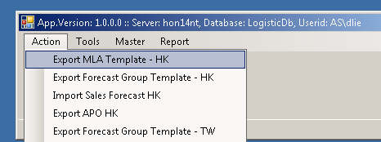

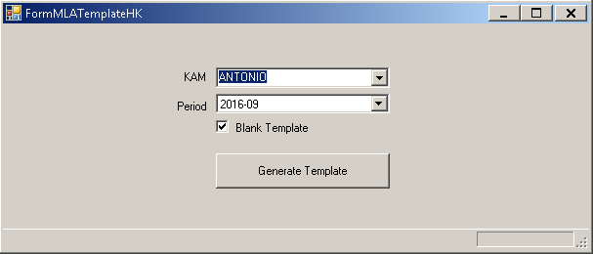

Period: is the first month shown in your template

Blank Template :

checked : no sales forecast data displayed

unchecked : display data from previous import

* Click Generate Template Button

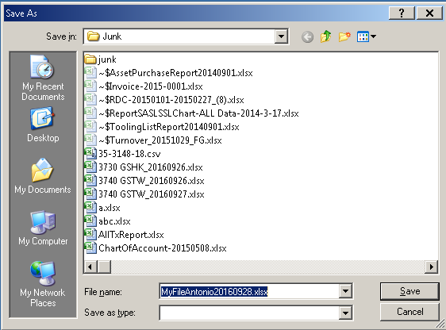

* Select the Folder Destination, click Save Button to continue.

## HK Forecast Group Template

Action > Export Forecast group Template – HK

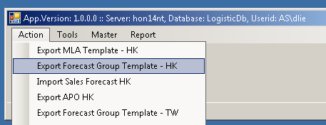

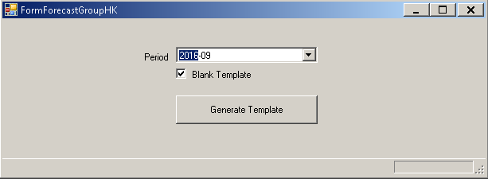

Period: is the first month shown in your template

Blank Template :

checked : no sales forecast data displayed (month 7 to 12)

unchecked : display data from previous import (month 7 to 12)

For month 1 - 6, the data coming from MLA Sales Forecast.

* Click Generate Template Button



* Select the Folder Destination, click Save Button to continue.

## TW Forecast Group Template

Action > Export Forecast Group Template – TW

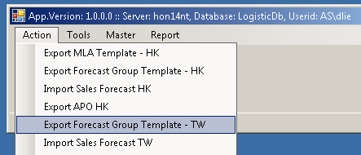

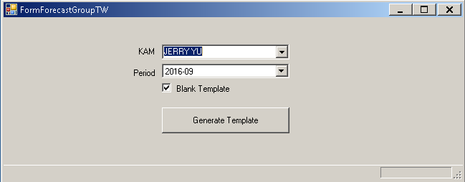

Period: is the first month shown in your template

Blank Template :

checked : no sales forecast data displayed

unchecked : display data from previous import

* Click Generate Template Button



* Select the Folder Destination, click Save Button to continue.

# Import Excel Template to Database (HK/TW)

Action > Import Sales Forecast

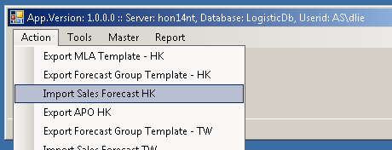

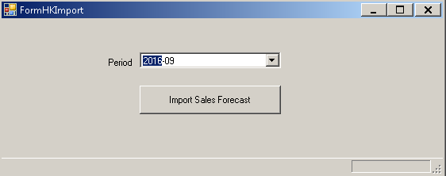

* Click Import Sales Forecast Button

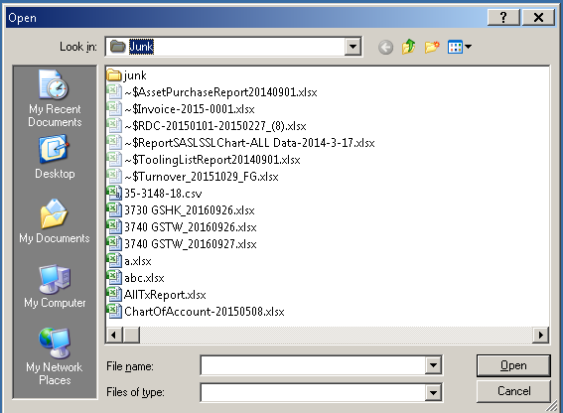

* Locate your file, Click Open button to continue.

# Export APO Excel File (HK/TW)

Action > Export APO

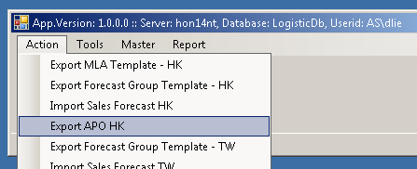

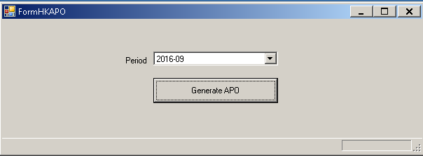

* Click Generate APO Button



* Select the Folder Destination, click Save Button to continue.

# Master File

## CMMF HK

Master > CMMF > CMMF HK

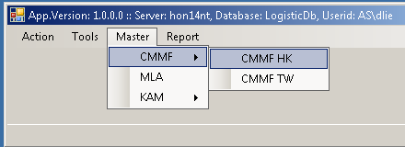

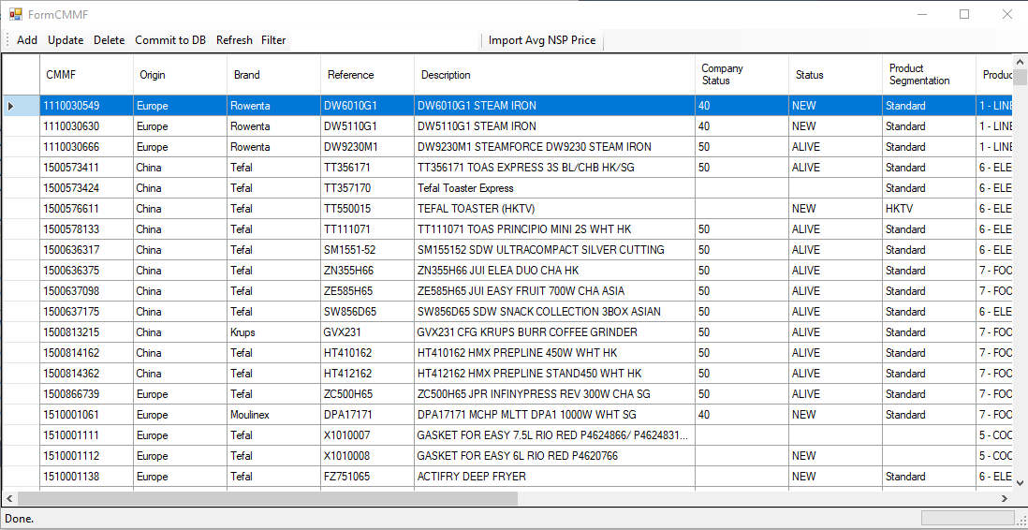

Dialog CMMF for Add or Update

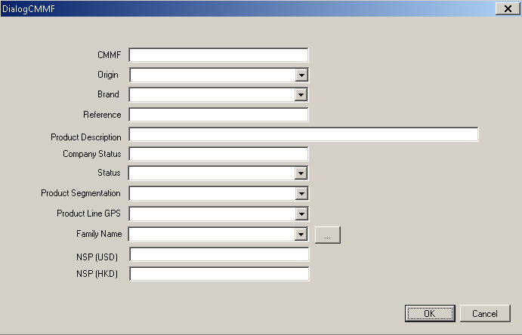

Note:

After you modified the record(s) (Add, Update, Delete), you MUST click button Commit to DB, to save your modification to Database.

Import AVG NSP Price

Text file type : CSV

Format:

CMMF, AVG NSP (USD), AVG NSP (HKD)

Sample data:

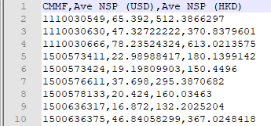

## CMMF TW

Master > CMMF > CMMF TW

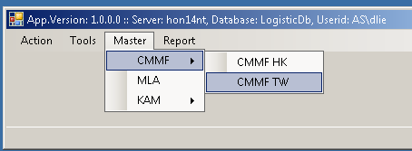

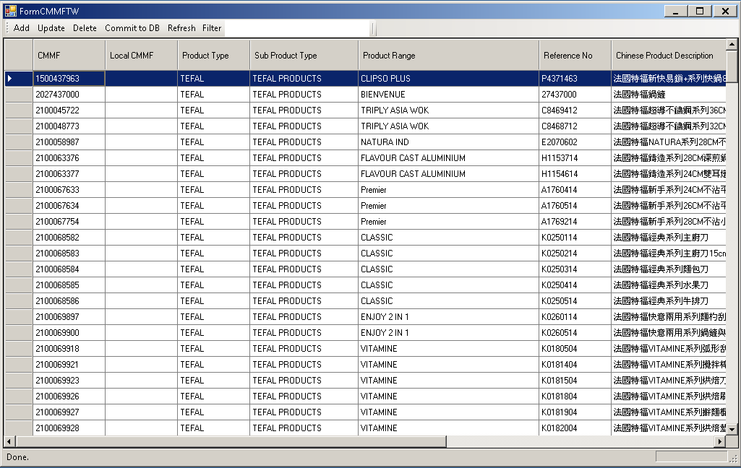

Dialog CMMF for Add or Update

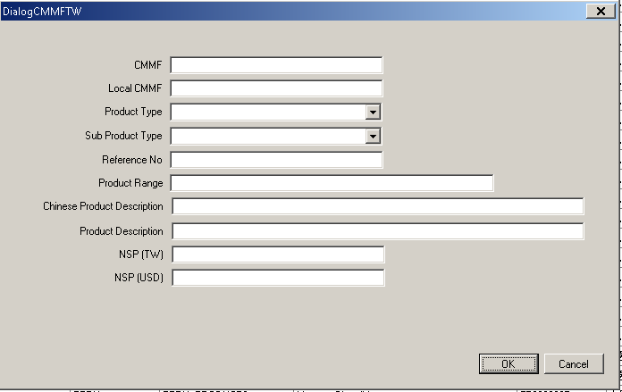

Note:

After you modified the record(s) (Add, Update, Delete), you MUST click button Commit to DB, to save your modification to Database.

## MLA

Master > MLA

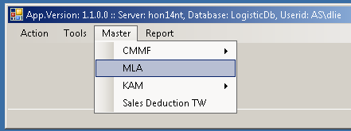

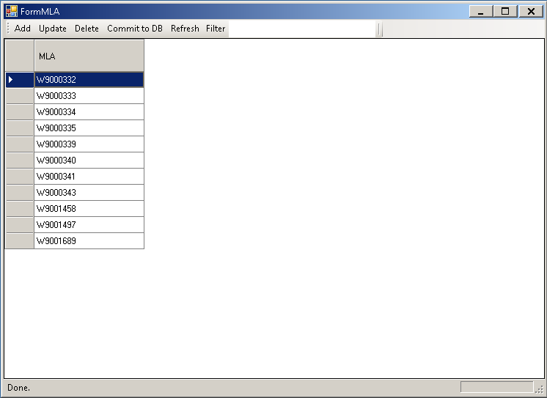

Dialog Interface Add or Update

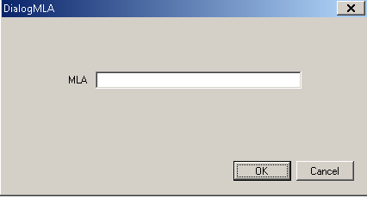

## KAM Target HK

Master > KAM > KAM Target HK

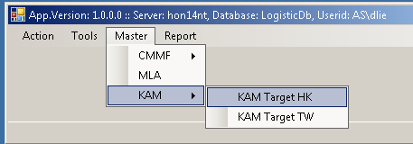

Note:

After you modifiied the record(s) (Add, Update, Delete), you MUST click button Commit to DB, To save your modification to Database.

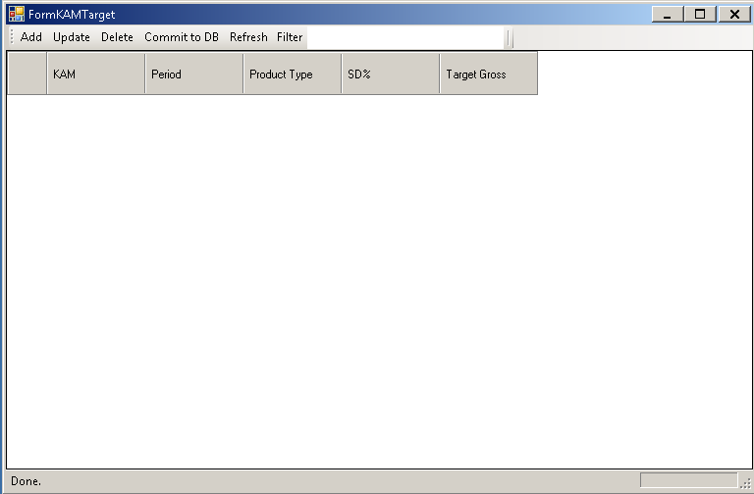

Dialog Interface for Add or Update

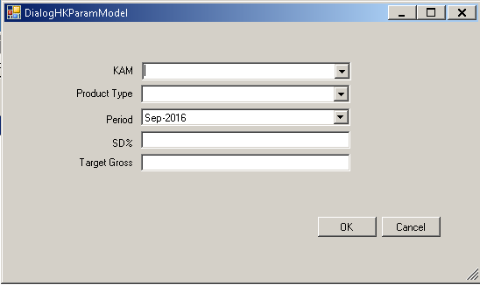

Note:

After you modifiied the record(s) (Add, Update, Delete), you MUST click button Commit to DB, To save your modification to Database.

## KAM Target TW

Master > KAM > KAM Target TW

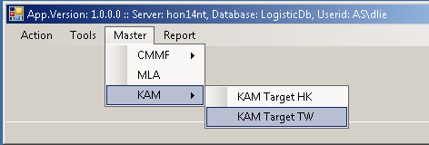

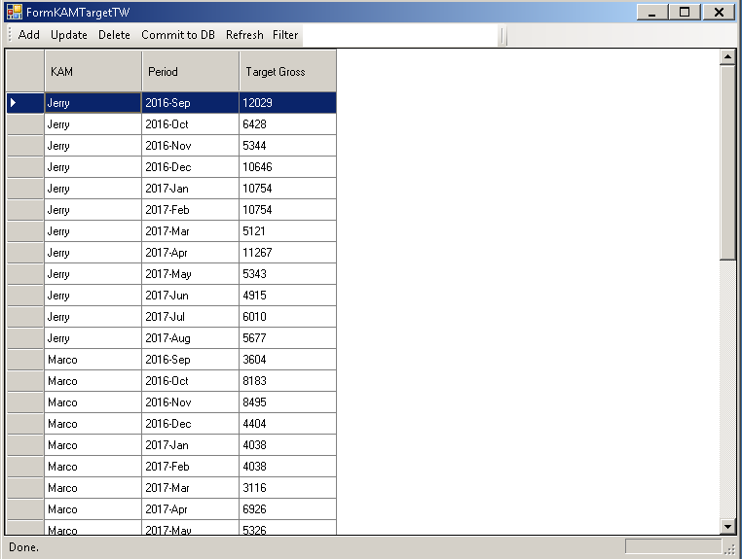

Dialog Interface for Add or Update

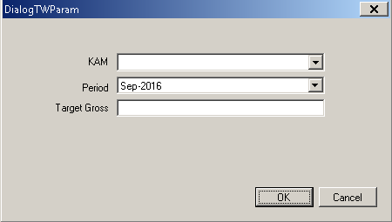

Note:

After you modifiied the record(s) (Add, Update, Delete), you MUST click button Commit to DB, To save your modification to Database.

## Sales Deduction TW

Master > Sales Deduction TW

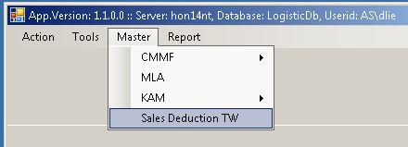

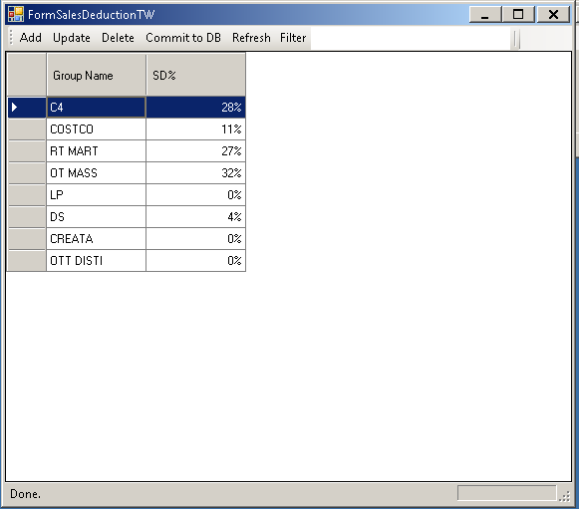

Finish